Planning & Environment – Robin’s update for Committee, 30 June 2022

BSoc PLANNING & ENVIRONMENT SUB-COMMITTEE
The current composition of the Sub-Ctte is me (BSoc Lead), Derek (BSoc Officer),
Guy (Conservation Area & Listed Building cases), Simon Kaufman (bigger architectural projects), Nick Saul (special and infrastructure cases), Susan (heritage matters), Andreas & Simon Watson. Additional members with expertise in planning law, landscape and/or the environment would be welcome.

- Main Committee: Please ratify the P&E Sub-Ctte membership

PLANNING ISSUES

Government

Theresa Villiers MP has made trenchant comments on proposals for the planning system contained in the Levelling-up and Regeneration Bill currently before Parliament. Samples:

‘The Bill has a welcome focus on better design, but this does not resolve the problems which I and my colleagues have been raising. Loss of precious green space remains problematic, even if what is built on it is well designed. A block of flats is still a block of flats, no matter how tastefully it is presented.

If they go under the bulldozer, our green fields are lost forever. If suburban areas like my Chipping Barnet constituency are built over by high rise blocks of flats, they are damaged and changed forever. Ministers are clear that they are willing to listen. So I very much hope that before the LUR Bill completes its way through Parliament, we will see it amended and strengthened so that we clip the wings of an increasingly over-mighty planning inspectorate, we restore the primacy of local decision-making, and we safeguard the places in which our constituents live.’

London Green Belt Council

LGBC website – Simon W is helping to fine-tune the website for re-launch on 13 July. I hope to arrange a video-shoot of the LGBC’s Chair, Richard Knox-Johnston, speaking on the vital importance of the Green Belt from a site in Barnet.

Transport

84 bus – The new Councillors will be meeting TfL about improvements to local bus services, but aren’t optimistic about restoring the link between Barnet & Potters Bar.

Barnet Council

New Labour Council – Has declared a Climate Emergency and is setting up a citizen’s assembly. Any volunteers to represent BSoc?

- Ctte: Nominate volunteer(s) for the citizen’s assembly.

North London Waste Authority (Barnet is a member)

Edmonton incinerator – There is growing public concern about the environmental shortcomings of the proposed (estimated cost £800m).

Enfield Council

Enfield RoadWatch has launched a petition against proposals to build on the Green Belt as part of its Local Plan. 29 of Enfield’s 63 Councillors are new since the Plan was drafted.

Hertsmere

Since standing down as Conservative Party Chairman, Oliver Dowden MP may be able to spare more time protecting his constituency’s (and our) Green Belt.

RECENT CASEWORK (SELECTION)

Green Belt cases

40 Barnet Lane (former cricket pavilion) – The planning application to re-purpose this for the Rainbow Centre has been withdrawn. The reason for withdrawal isn’t given on the portal.

Land off Mays Lane, Greengate Stables – We supported an application by Strength & Learning Through Horses Another for the first stages of their project, subject to conditions to protect habitat and wildlife. SLTH’s Matt Bannon has been elected to the BSoc Committee.

Gaelic football pavilion, King George’s playing field – Decision still awaited on this replacement for a previous pavilion. We were neutral.

Arkley Riding Stables, Hedgerow Lane – Having lost last year’s appeal the developer is back, this time with three instead of four single-storey houses, each on the footprint of derelict buildings. We’re neutral, but have asked for planning conditions to protect the existing habitat, wildlife and a possible WWII gun or observation post.

Sky Studios expansion, Rowley Lane – Sky is consulting on a proposal to expand the number of sound stages on its Rowley Lane site to 23, on 26 hectares of Green Belt land. Hertsmere’s recently-abandoned draft Local Plan would have more than doubled the area available for studios (and of course its successor could also do so).

Conservation Areas & Listed Buildings

1 Church Passage – We don’t always oppose roof extensions, but this one above L’Antica Pizzeria was bizarre. We objected and it’s been refused.

60 High Street (Balady) – We objected to this brash new shopfront, and the Council has refused the advertisement signage because ‘by reason of its size, scale, siting, illumination and design, [it] would fail to preserve or enhance the character of the locally listed host property and the wider Wood Street Conservation Area, and would be detrimental to the visual amenities of the area.’ Too right; where that leaves the rest of the shopfront remains to be seen.

70 High Street – We strongly objected to the latest application. A decision is awaited.

98-100 High Street (fka Foxtons) – Proposed enlargement of the long-neglected Foxtons building into ground-floor co-working employment space with 12 flats above. See ANNEX 1 for details.

- Ctte: Decide whether to support, be neutral, object or not comment at all.

118 High Street (fka TSB Bank & Barnet Press) – A proposal that will have BSoc founder & former Barnet Press owner Gwyneth Cowing turning in her grave. It comes in two parts:
- Application for a ‘bingo’ licence.
- Application for alterations to this Grade II building.

- Ctte: Decide whether to support, be neutral or object.

2 Clyde Villas, Hadley Green Road (LL) – This application for 15 flats for people with special needs is virtually unchanged since last year’s. We’ve objected again.

81 advertising banners on lamp-posts, High Street/Barnet Hill – We objected. Still no decision.

33 Lyonsdown Road – The owner applied to demolish under Permitted Development Rights (PDR) – despite its being locally listed, and redevelopment having been refused by both the Council and Planning Inspectorate. We objected unsuccessfully. See ANNEX 2 below for details.

- Ctte: Approve the actions proposed in ANNEX 2 below.

Tudor Park pavilion

- Simon C to report.

Planning decisions awaited

152 High Street – Another proposal for extension up to the roofline of neighbouring buildings. We objected because it would appear even taller and was poorly designed.

Land behind 36 Park Road – Nine new houses with gardens on vacant land behind it. We supported it.

Former public WCs, Great North & Station Roads – After consulting the Committee, we were neutral about this proposed internet café but sceptical about many details, especially the risk of its becoming a billboard.

Western half of Meadow Works site, Pricklers Hill (8 x 3-storey houses) – We supported these new family homes and gardens.

Planning appeals dismissed

33 Park Road – For six years the owner has been trying to build on the roof of this block of flats. Last year he tried again under the government’s relaxed Permitted Development Rights, but was again refused. He appealed, we opposed his appeal, and the Planning Inspector has just dismissed the appeal.

202 High Street (fka Bentleys) – We opposed overdevelopment (commercial plus 6 flats).

204 High Street (fka Statons) – We opposed overdevelopment (6 flats).

Planning appeal decision ignored

1 Sunset View – The owner was given six months to make good unapproved alterations to Locally Listed house in Monken Hadley CA. Nothing appears to have been done.

Planning appeal decisions awaited

Barnet House, Whetstone – We submitted a representation against development of the slab and its surrounding site. A public inquiry was held in May, but a decision is awaited.

Crown & Anchor, 47 High Street – Following our objection to lack of detail in the planning application, Guy & I met the owner. He’s ignored our advice about replacement windows and doors and appealed against the Council’s refusal. We’ve submitted a representation supporting the Council’s decision.

Victoria Quarter – A Public Inquiry will start on 19 July. We submitted a representation against the latest development. The developers will be represented by Lambert Smith Hampton. Their letterhead gives a clue as to their design preferences…

ANNEX 1

98-100 High Street (fka Foxtons) – Proposed enlargement of the long-neglected Foxtons building into ground-floor co-working employment space with 12 flats above. See the planning portal for full details: https://publicaccess.barnet.gov.uk/online-applications/applicationDetails.do?keyVal=RCR5B1JIFGI00&activeTab=summary

The Society has long campaigned for mixed-use projects of this kind (e.g. our support of the original Brake Shear House development along the High Street), and Simon Kaufman Architects have submitted a fuller and better-considered proposal than the skimpier documentation usually submitted.

So we’re pleased, but there’s a snag: we can’t automatically support it because Simon is a Committee member. For a site of this sensitivity, it's important for the Committee as a whole to agree its view.

The previous Ctte was consulted earlier this month. For what it’s worth, the full Ctte voted 5:2 in favour, with 6 neutral and 2 abstaining (including Simon Kaufman). The previous P&E Ctte, which included two non-Ctte member advisors, voted 4:2 in favour, with 2 neutral (and Simon abstaining). Below is a box summarising the main arguments pro and con.

But we now have a new Ctte, you have had time to reflect and the deadline for comments is 4 July.

- Ctte: Decide whether to support, be neutral or object.

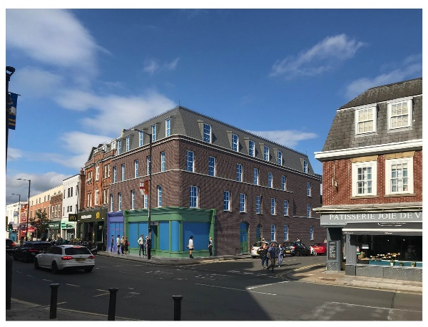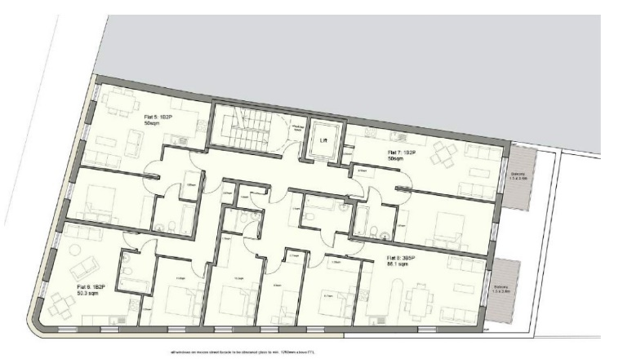
High Street view 2nd floor plan
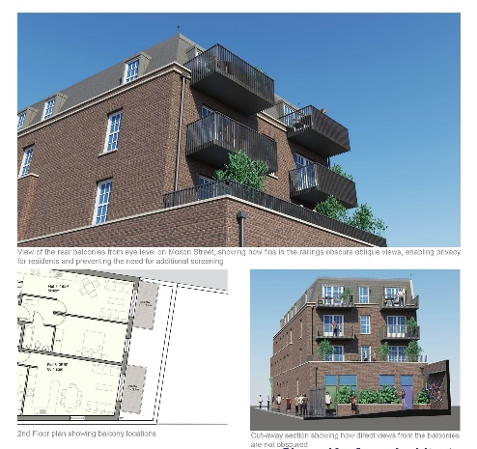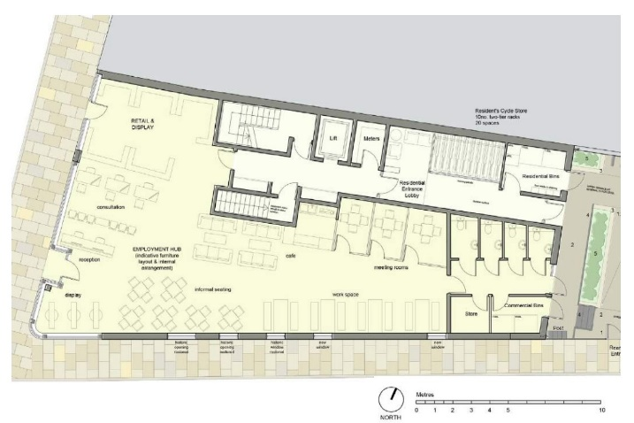
Moxon Street view Ground floor plan

It’s quite a substantial change in the mass of the building compared to existing.
Doubling in height of the existing buildings…is an over-development of the site. The proposal will damage and erode the historical character and integrity of the existing buildings, which probably date from the early 19th century, if not before in the case of no.100. The bulk and size of the proposed block would be an overbearing presence in both the High Street and also in Moxon Street, where the majority of buildings are two storey. It would also be inconsistent with our position on the proposals for Church Passage, where we have pushed back against additional storeys.
I would support the addition of one storey, designed so that its negative impact on its neighbours in the High Street and Moxon Street and the character of the Conservation Area is minimised.
Although the change in massing from the existing is rather startling, it does not seem to me to be drastically out of context.
Were the interior interest/survival to be demonstrated as minimal, I would be comfortable with an upward extension of one storey, so designed as to have minimal visual impact and to be of a design in keeping…My fear is that all the lower rise buildings in the High Street will be upwardly extended in a race to four storeys and we will end up with a gloomy tunnel which won't retain conservation area status.
I felt the building was somehow oppressive and a bit overbearing. However I recognise something has to be built there and this is probably a lot better than could have been proposed. It does fit in with the colour of the bricks and the height so I was going to suggest we were neutral.
It’s not just the startling increase in bulk but mainly the brick colour that I find so off-putting. If the brick colour were the same as the buildings each side (Joie de Vie and McDonald’s) I would find it less forbidding and off-putting.
Mixed use looks good, but….affordable housing meaning affordable to whom? Do we know the terms of the affordable housing proposed?
We do need urgently more dwellings and, in a way, this a ‘brownfield’ (underdeveloped) urban site of the kind that we keep arguing should be exploited.
Good to see some balconies but they are very small on 2nd and 3rd floors.
There is no shared amenity space for the flats. There is no provision for doorstep play.
Ideally more work should be done to establish the date and significance of 98-100 - the evidence of maps suggests that no.98 dates from when Moxon Street was created c.1826 and the different roofs suggests that no.100 pre-dated the laying out of Moxon Street.
Much as I like history... I wonder how practical it is to be pushing for investigations into every building on the high street. But then again, they are important historic buildings!
98-100 is not a listed building but it is in the conservation area. For what is in effect a facadist proposal, I think that this is insufficient as far as recording and analysis of the heritage asset goes.
Of course, if the interior is of heritage significance like no 54A that would be a incontrovertible reason for preservation but I am sure that Simon K would have shared that view.
I'd feel deeply uncomfortable if we opposed the application as it has considerable merits - height aside, I think it's respectful aesthetically and I like the solar panels on roof / green roof.
The building would benefit from integrating features to support biodiversity on the eastern facade - such as integrated bird boxes.
The facade on Moxon Street and to the rear could support urban greening through the use of vertical climbers.
The green roof should be of a biodiverse mix to support wildlife.
It looks to me like the sort of considerate proposals we should support. It is a big improvement on existing, and I like the overall look of the scheme and retention of the curved edge.
The Moxon Street pavement is very narrow - as it stands the proposed approach route for the residential flats and the servicing for the commercial or private residential flats is likely to impact on the public highway.
The bin for the residential and commercial bins are in very tight spaces and how will the sequence of bin collection work?
Both the residential and commercial bin stores are very tight.
I also support the proposed redevelopment of 98-100 High Street – and let’s hope the intention of providing affordable accessible work/retail space on the ground floor become a reality. It would certainly help to re-habilitate the scruffy Moxon Street/High Street junction.

ANNEX 2

33 Lyonsdown Road – The owner applied to demolish under PDR – despite its being locally listed, and redevelopment having been refused by both the Council and Planning Inspectorate. We objected unsuccessfully.

We heard at the end of May that Abbeytown, a subsidiary of Martyn Gerrard, had made two applications (under differing legal clauses) to demolish the building under PDR. The public was not invited to comment on them, but we discovered that we could submit comments by mid-June. Guy sought urgent advice from a solicitor specialising in historic buildings who advised that there were legal grounds for the applications to be refused.

Guy also met local Councillors and Theresa Villiers MP was informed. All were sympathetic but thought they had no power to intervene.

Action was urgent, and demolition of No.33 would set a very bad precedent for other locally listed buildings, I therefore asked the BSoc Executive Committee for approval to pay £792 for a solicitor’s letter opposing the first of the applications. The ExCo approved and the letter was submitted. The Exco also agreed that, if necessary, an additional fee could be paid for another letter opposing the second application, subject to donations being sought from local residents.

Lyonsdown Road residents responded magnificently, donating £450 to the Society. Susan also most generously offered to lead as many walks as it takes to pay for the second letter.

The Council approved both applications on 21 June, before the second letter could be sent.

Issues for decision

- Endorse the ExCo’s decisions.
- Approve payment of a token contribution to the solicitors for their preparatory work on a second letter.
- Consider what, if anything, we can do next.
- Appoint a sub-group (Robin, Guy, Susan + someone else?) to investigate possible further action, and to report to the ExCo if any further expense would be involved.

